Sahas Roodkee
Lab Two: PowerShell Scripting
IS 3513-01T
July 13, 2025
Professor Wooldridge

When I first heard that we’d be working on a PowerShell script to analyze Windows System Security Logs, I must admit—I felt nervous. Even though I’ve got solid experience in languages like Python and C#, PowerShell was something new for me. I was stepping into unfamiliar territory, and the idea of working with logs, scripts, and commands that I barely understood was honestly a little overwhelming.
Still, I knew this lab wasn’t just about checking a box. It was a chance to learn, even if it meant struggling a bit at first.
Like any beginner, I started where most of us do: the instructions. I read through them carefully, trying to make sense of what exactly was expected. It quickly became clear that I’d need to write a PowerShell script that could analyze events from the Windows System Security Log—a task that sounded technical and way out of my comfort zone.
To give myself a bit of a boost, I opened the PowerPoint slides that were shared for the lab. That’s when I discovered something cool—PowerShell ISE. I had never used it before, but I loved how it combines a scripting window and console in one place. It reminded me a lot of the IDEs I’ve used for other programming languages. It was a small thing, but it made the whole experience feel a bit more approachable.
From there, I dove into researching the basics. I started looking up how to navigate in PowerShell, how to work with files, and what commands I needed. I found out about using things like $HOME\Documents to access folders, or .\filename to reference files. They were small discoveries, but each one helped build my confidence.
Once I felt like I had at least a tiny grasp on the basics, I started writing my script. And wow—it was messy. I mean messy. It was the definition of spaghetti code: unstructured, confusing, and held together by a prayer. But it was my code, and I was proud that I even got something written at all.
Unfortunately, when I tried running the script on my computer, nothing happened. PowerShell couldn’t recognize the file, and I couldn’t figure out why. I tried different file paths, double-checked extensions, Googled the error messages, nothing worked. That moment was frustrating. I had put in the time and effort, and I felt stuck.
Then I remembered something from the instructions: we could use the virtual machines provided by the professor. I quickly logged into the virtual lab space (SpaceSim) and accidentally opened the wrong VM—Kali Hunt—but I caught my mistake and switched over to the right one: win-hunt-01.
Once I was in the right VM, I searched for PowerShell ISE, opened it, and was ready to go. My plan was simple: copy and paste the code I had already written on my local machine. Easy, right?
Nope. The VM wouldn’t let me paste the code. I wouldn’t lie, that moment nearly broke me. After all the stress and troubleshooting I had already been through, now I had to rewrite everything from scratch. But instead of getting discouraged, I took a deep breath and told myself, “You’ve done it once. You can do it again—this time, even better.”
And that’s exactly what I did. I rewrote the entire script, and this time it only took me about 30 minutes. Rewriting it gave me the chance to organize it better and clean up my logic. It felt good to see my progress—even if it was only a small step.
When I ran my script for the first time on the VM, I got an error. Turns out, I had missed a few brackets. Thankfully, that was an easy fix. But when I ran it again, it still didn’t produce the results I was hoping for.
This is when I realized something important: I hadn’t read the instructions as carefully as I thought.
Going back through the assignment details, I noticed that the output needed to be formatted in a very specific way. Not only that, but the script was supposed to filter and display certain types of events. I had completely overlooked that part.
So, it was back to research mode. I Googled more PowerShell examples, learned about commands like Get-EventLog and Get-WinEvent, and experimented with different filtering methods using Where-Object. I also learned how to adjust the formatting of the output so that it looked clean and made sense for the report.
Eventually, I got it working. My code finally returned something meaningful. I was honestly shocked when I looked at the clock, it was already 6:30 PM. It started around 4:00 PM, and the hours had flown by. Even though it had taken time, the feeling of accomplishment was totally worth it.
Just when I thought everything was done, I noticed another problem: my script was returning zero results. Every time I ran it, it looked like the system hadn’t logged any relevant events at all.
I suspected this might be because I was using a virtual machine, and maybe the event logs were empty or hadn’t recorded any real activity. But as a beginner, I wasn’t totally sure if that was the problem or if I had missed something else. I tried a few more tweaks, but eventually I decided not to get stuck in an endless loop of troubleshooting.
Instead, I grabbed the screenshots I needed, skipped the Excel export since there wasn’t much data to work with, and started writing my lab report. Then I saw .csv worth 20 points so tried the script on my computer and had the same result. So, I exported the .csv file to prove my results.
Looking back, this lab was more than just a coding assignment. It was a true learning experience. I made plenty of them. I got confused, frustrated, and even tempted to quit at one point. But I didn’t. I kept going, and that persistence paid off.
Here are some of the biggest lessons I took away from the lab:
Start with the basics. Even if it seems small, understanding commands like cd, .\, or $HOME helped me get grounded in a new language. Don’t ignore the documentation. The instructions were clearer than I thought, once I really took the time to read them. Things will go wrong—and that’s okay. Whether it was code errors, file access issues, or virtual machine problems, I had to learn to adapt. Every mistake is a learning opportunity. I didn’t just write code—I rewrote it, improved it, and learned why it worked (or didn’t). Progress is more important than perfection. The script might not have returned the perfect data, but I now understand PowerShell way better than I did a week ago.
If you had asked me before this lab whether I was comfortable working with PowerShell, I would’ve said no way. Now, while I’m still a beginner, I feel much more confident. I’ve seen how powerful the tool is and how it can be used to do real system-level analysis. That’s something I never thought I’d be able to say.
More importantly, I proved something to myself. I learned that I could take on something completely new, get stuck, feel frustrated—and still make it through. That resilience is something I’m proud of.
So yes, this lab was tough. Yes, it took hours. But in the end, it wasn’t just about writing a script. It was about growing as a learner, a problem-solver, and a coder. And that’s a win I’ll carry with me far beyond this assignment.

Figure 1. Script Results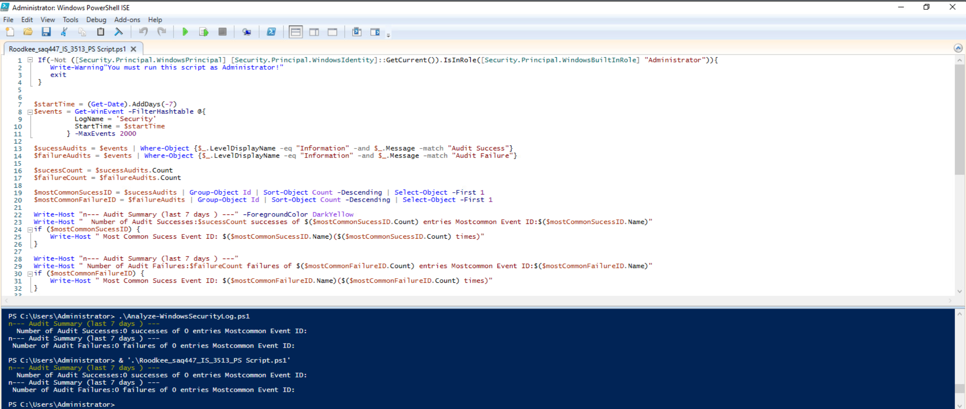
Figure 2. Script results on my computer.
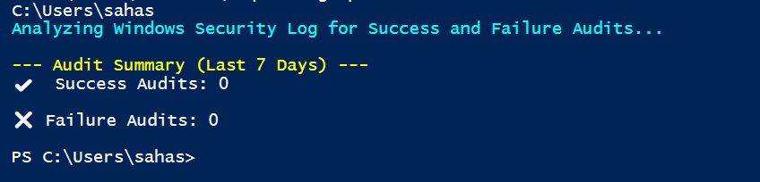

Figure 3. My CVS File
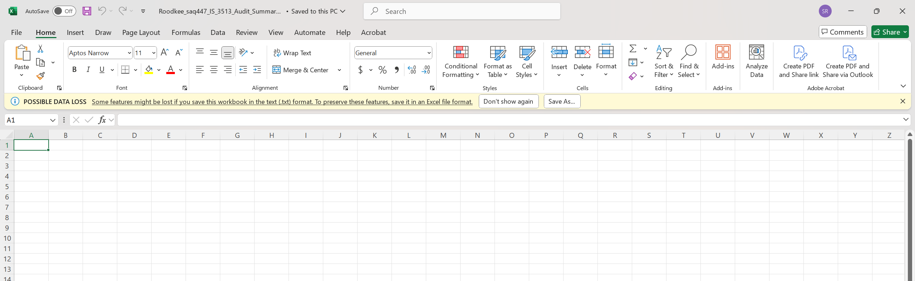

Figure 4. My Code I used in my computer
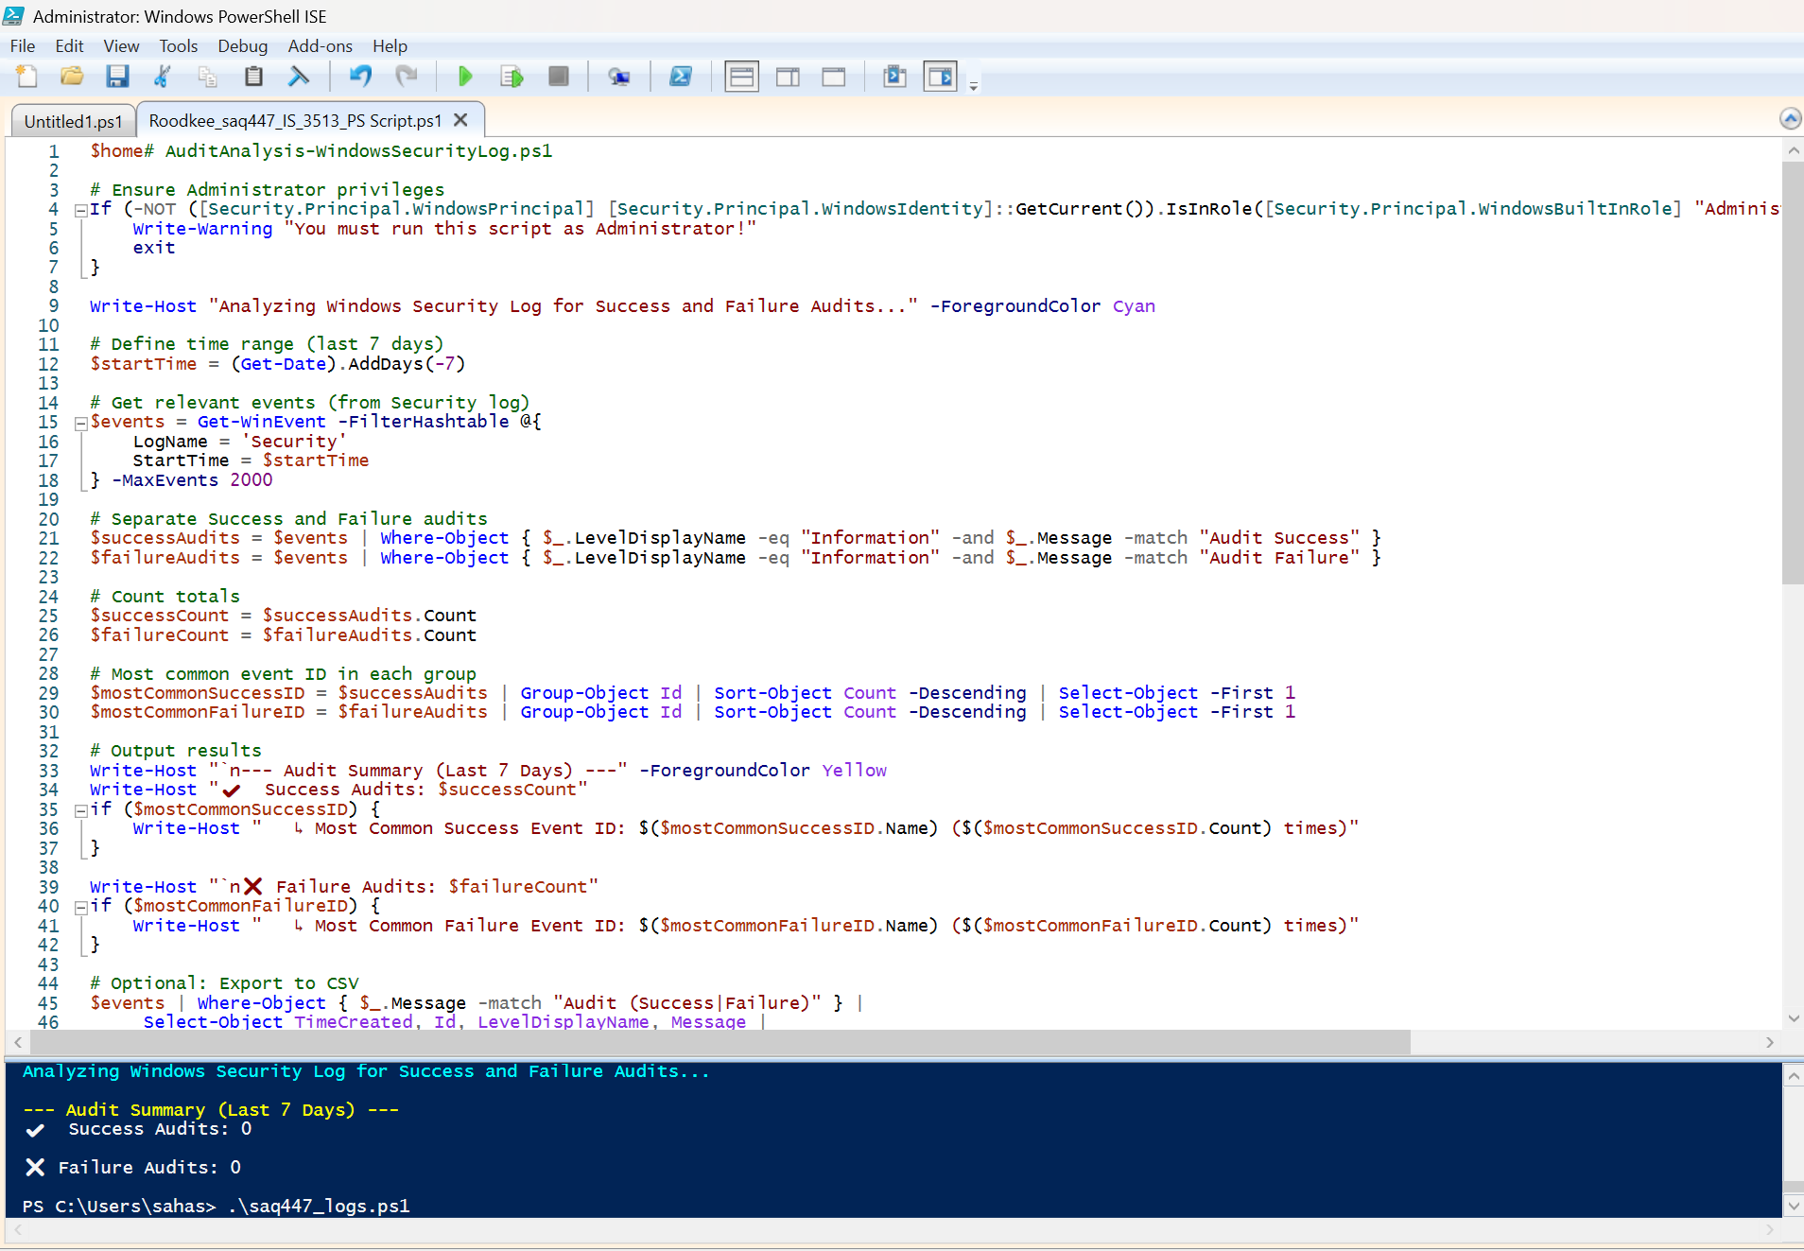

In this Lab report I will try to understand why PowerShell is so important in our field, let’s walk through the who, what, when, why, and how and look at how it fits into a modern cybersecurity professional’s day-to-day work. When you’re working in cybersecurity, there are some tools you simply can’t afford to overlook, and I believe PowerShell is one of them. It was originally designed to help Windows system administrators manage computers more efficiently, PowerShell has become a must know skill for defenders, analysts, and even ethical hackers. It’s incredibly powerful and like any powerful tool, it can be used for both good and bad.
PowerShell is widely used by system administrators, IT engineers, threat hunters, and of course, cybersecurity professionals. But here’s the twist—it’s also used by hackers and malicious actors. That’s what makes it so important to understand.
Cyber attackers have figured out that PowerShell lets them run stealthy, script-based attacks that can bypass antivirus tools. It’s part of a broader technique called “living off the land,” where they use built-in system tools instead of downloading obvious malware. As defenders, we must know how PowerShell works—not just to use it ourselves, but to recognize when someone is using it against us.
PowerShell is a command-line shell and scripting language developed by Microsoft. At first, it might look like the Command Prompt, but it’s a lot more powerful. Unlike traditional shells that only deal with plain text, PowerShell lets you work with rich data objects meaning you can filter, format, and manipulate data more precisely.
It comes with built-in commands called cmdlets, and it taps into Windows Management Instrumentation (WMI), the registry, and even Active Directory. This gives you serious power to manage and investigate systems across your network (Jones, 2020).
Cybersecurity professionals use PowerShell at just about every stage of their workflow. Before an incident, to automate routine system audits, apply security configurations, or run compliance checks. During an incident, to search logs, isolate compromised machines, or disable suspicious accounts. After an incident, to gather forensic data, analyze attack behavior, and document everything for future learning.
It’s not just defenders either. Penetration testers and red teamers rely on PowerShell frameworks like PowerSploit, Empire, and Nishang to simulate real world attacks (MITRE, 2023). The MITRE ATT&CK framework even lists PowerShell (T1059.001) as one of the most common techniques used by threat actors to execute scripts and commands on target systems (MITRE, 2023).
If you’re defending Windows environments. PowerShell is already on every machine you’re responsible for. That makes it one of the most accessible and powerful tools in your toolkit. This matter because It’s already built into Windows, so it’s everywhere. It gives you direct access to critical system data like event logs, user sessions, services, and more. It’s perfect for automating repetitive tasks like exporting logs or checking for missing patches. And importantly, it’s a tool that attackers are using so we need to be able to detect and stop them (Bloor, 2021).
When attackers use PowerShell, it often doesn’t look like traditional malware. They might encode their commands in base64 or spawn PowerShell from unexpected parent processes like Excel. Knowing these behaviors helps you build more effective detection rules and incident response plans.
Some real-world examples of how you might use PowerShell in a security role.To investigate failed login attempts we can use the code “Get-WinEvent -LogName Security | Where-Object { $_.Id -eq 4625 }”. To check when users last logged in “Get-ADUser -Filter * -Property LastLogonDate | Select-Object Name, LastLogonDate”. To disable a compromised user account “Disable-ADAccount -Identity "sachin"”. Looking for suspicious processes “Get-Process | Where-Object { $_.Path -like "*temp*" }”. PowerShell also helps you respond faster. For example, instead of manually logging into every machine, you can run scripts across multiple systems remotely. This saves time during high-pressure situations like active incidents.
If you’re working in cybersecurity—or training to enter the field—PowerShell is worth learning early. This is how it benefits you personally. It makes you more efficient—by automating tasks you’d otherwise do manually. It makes you more effective—by giving you deeper access to the systems you’re protecting. It makes you more prepared—to respond quickly to threats using scripting and automation. And it gives your insight into attacker techniques, which makes you a better defender. As Jones (2020) points out, learning PowerShell gives professionals an edge in managing and securing Windows environments. And in today's threat landscape, that edge can make all the difference. Learning PowerShell doesn't just make you better at your job, it makes you a more strategic thinker. As Jones (2020) explains, understanding PowerShell gives you a deeper connection to how Windows systems really work, which is something that every great cybersecurity professional should aim for.

I want to conclude the PowerShell isn’t just a scripting language for IT admins anymore, it’s essential to cybersecurity. Whether you’re tracking down suspicious user activity, automating alerts, or trying to understand how attackers think, PowerShell gives you the tools to act quickly and confidently.
The fact that attackers rely on PowerShell only makes it more important for us to learn it. Because when we understand the tools they’re using, we’re in a much better position to stop them. This lab gave me the opportunity to explore PowerShell hands-on, and although it was challenging at times, it helped me gain a deeper appreciation for what this tool can do. From now on, I won’t just think of PowerShell as a scripting language—I’ll see it as one of the most essential tools in my cybersecurity arsenal.

Bibliography
Bloor, R. (2021). PowerShell for cybersecurity: Getting started. Syngress.
Jones, D. (2020). Learn PowerShell in a month of lunches (4th ed.). Manning Publications.
MITRE. (2023). ATT&CK technique T1059.001 - PowerShell. Retrieved from https://attack.mitre.org/techniques/T1059/001/

